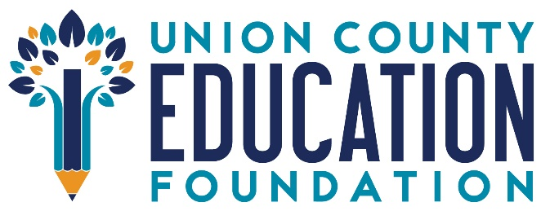

**Why “Foundation” Doesn’t Tell the Whole Story**

When people hear the word *foundation*, they often picture large endowments, investment income, and permanent funds quietly sustaining programs behind the scenes. But that’s not the story of the **Union County Education Foundation**—and we think it’s important to share what truly makes us different.

Despite the name, the Union County Education Foundation doesn’t operate with an endowment. There is no financial cushion. Each year, we begin with a clean slate—and we raise every dollar we need from individuals, families, businesses, and community partners who believe in the power of public education.

This model means our work is powered entirely by people, not portfolios. It’s a reflection of the generosity, trust, and shared values of our local community. And the impact is real.

Thanks to community giving, the Foundation funds classroom innovation grants that spark creativity and engagement. We provide scholarships and academic resources that help students pursue their dreams. And most recently, we launched the *Erase the Need* store, offering free school supplies to Union County Public School teachers—so that every child has what they need to learn and thrive.

Each of these programs fills a gap that would otherwise go unmet. And because we raise what we give each year, the support we receive goes to work immediately, changing lives right here in Union County.

We’re proud of what we’ve accomplished together—and even more excited about what’s ahead. At the Union County Education Foundation, we may be a foundation in name, but in practice, we’re a grassroots movement powered by generosity, driven by purpose, and united by a belief that public education is worth investing in.

To learn more or get involved, visit [www.ucedfoundation.org](http://www.ucedfoundation.org).